|  |
| --- |
| New York Restaurant Inspection Results Executive Summary |
| Kartik Mathur(s5309927)  Manish Shrestha ( s5308120 )  Nivethaa Elangovan ( s5298899 ) 7810ICT Software TechnologiesOctober 8, 2023 |

# Abstract

The NYC Department of Health has conducted inspections around various restaurants in New York City which have been graded based on several factors. The data has been collected and documented for a period of seven years. The major factor of interest in this analysis is the various kinds of violations, criticality score and their distribution over suburbs. The main insight covers the analysis of violations caused by animals other than fish across different suburbs and their trend over time. As a variety of cuisines are found across the city, we aim to identify the cuisine that causes the most and the least violations.

# Introduction

The health and safety of customers is vital for a business to run successfully. It has become a crucial factor in the food industry with an increasing number of options available in the global market. Though governments have many rules and regulations to regulate food handling in these industries, it is undeniable that they have to be constantly monitored to ensure that these are followed.

This report aims to study the analysis results of inspections conducted across various restaurants in New York City. The data was collected by the NYC Department of Health. The inspection result includes a period of seven years from January 01, 2010, to August 29, 2017. The restaurants were inspected and graded based on violations caused by several factors. The violations had different codes assigned to them based on criticality. The restaurants that were graded low were re-inspected and graded again.

The major features of the data used for analysis include the suburb where the restaurant is located, violation codes and violation descriptions. The analysis covers a period of 12 months from January 01, 2016 to December 31, 2016. This report covers significant and relevant insights into the data.

# **Analysis 1: Analysis of Criticality**

The critical score of the inspection result plays a major role in determining the grade awarded to the restaurant. It determines factors like re-inspections that could be conducted for a re-evaluation. Figure 1 and Figure 2 show the inspection results that were retrieved for a period of 12 months from January 01, 2016 to December 31, 2016.

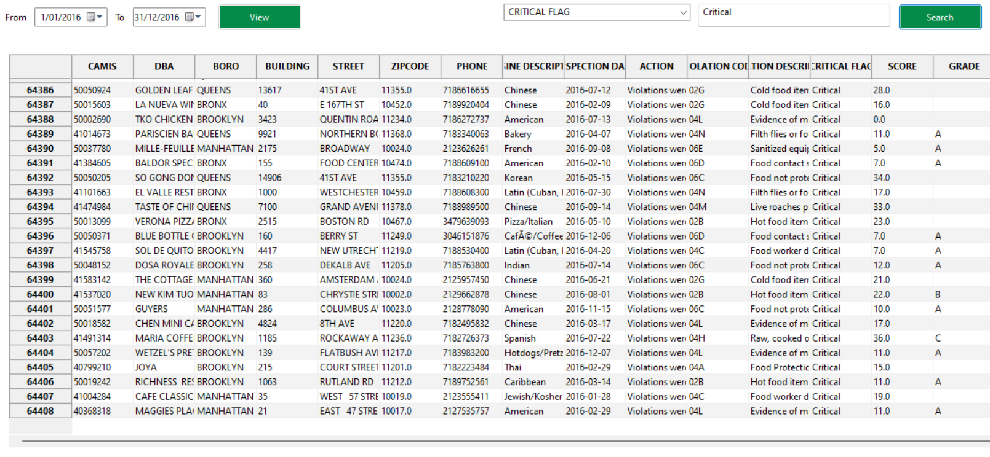

Figure Count of Critical Flags

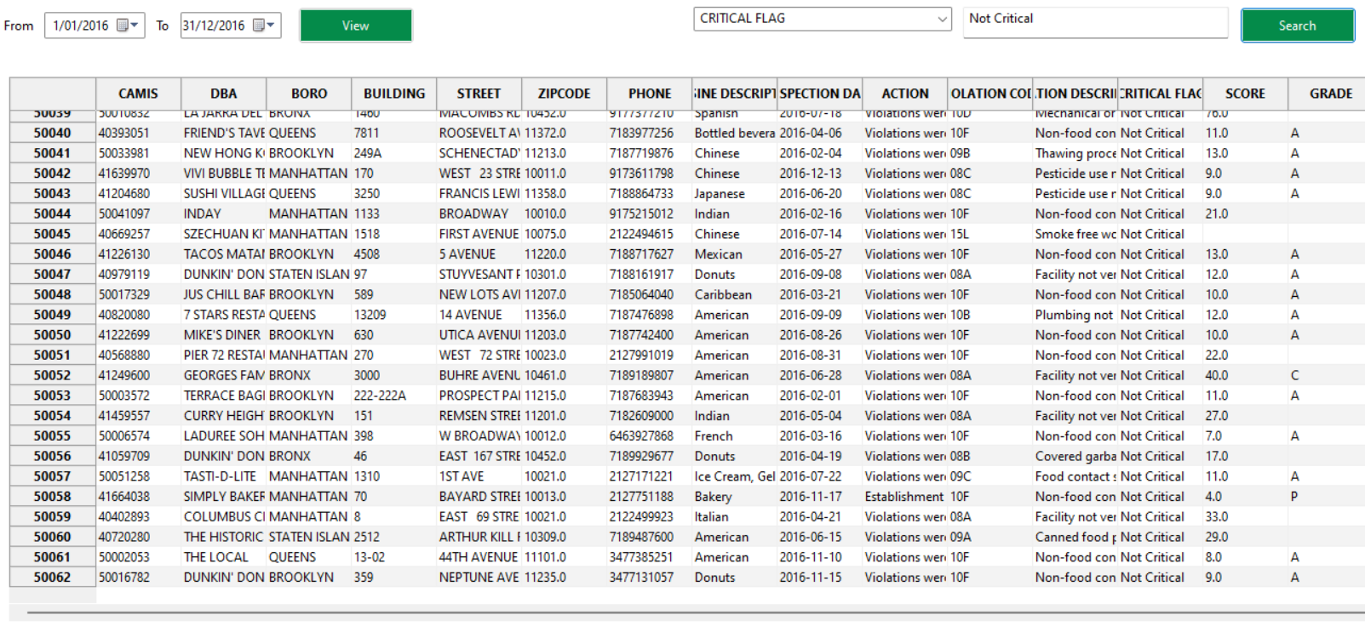

Figure Count of Non-Critical Flags

In the comparison of the results based on the count of critical and non-critical flags, it is observed that most of the violations caused by the restaurants were critical as the count of critical scores exceeds that of non-critical scores.

# **Analysis 2 Violation Distribution over Different Suburbs**

Figure 2 demonstrates the count of violations over different suburbs from January 01, 2016 to December 31, 2016.

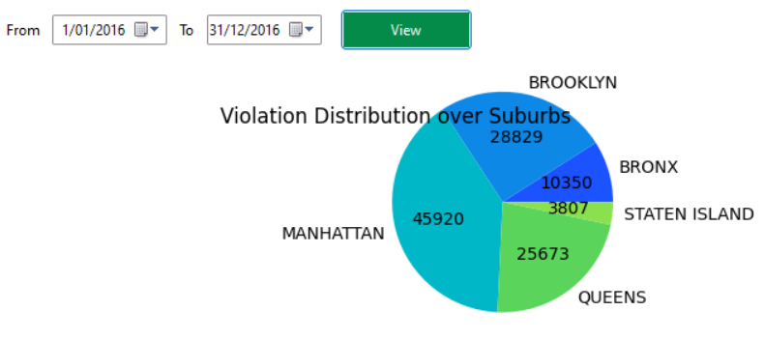

Figure Violation distribution over suburbs

According to the plot in Figure 3, it is observed that Manhattan has the highest number of violations. It is closely followed by Brooklyn and Queens with Staten Island accounting for the least number of violations.

Apart from the data analysed in the selected range, the count of violations follow a similar pattern across the entire data as shown in Figure 4.

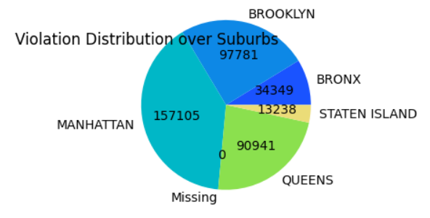

Figure Overall distribution of violation over suburbs

# **Analysis 3 Violations caused by living animals**

Figure 5 displays the count of violations caused by living animals other than fish. As we can see in the figure, the count of violations caused by flies for the selected date range is 6163.

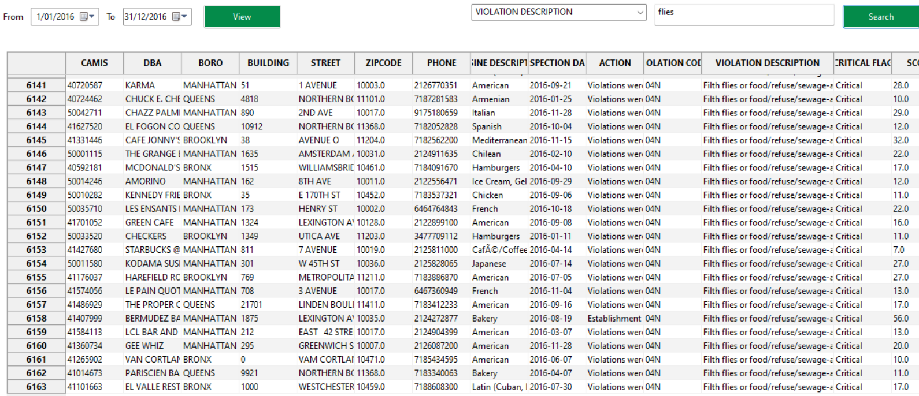

Figure Violations caused by animals

In a similar manner, violations related to animals can be viewed which are discussed in later sections.

# **Analysis 4 Violation related to animals**

## Trend over time

Figure 6 plots the cases related to animals over the selected date range.

Figure Violations related to animal

Figure 6, each line describes an animal. The months are denoted along the x-axis and the count in numbers is denoted along the y-axis. Each number on the x-axis denotes a month starting from 1 ranging to 12.

It is observed that the violations caused by rats and mice are almost ignorant as compared to the count of violations caused by flies and roaches. The count of violations caused by other live animals has almost remained constant over the period under examination.

The violations caused by flies has been on decrease until the month of May, 2016 after which it started increasing gradually and peaked by August, 2016. It again started dropping gradually by the Spetember, 2016. The count of roaches follows a similar pattern throught the period under analysis where it drops and rises significantly at regular intervals.

Figure Overall analysis of cases related to animals

Figure 7 displays the overall count of cases related to animals. As we can observe, the count of cases in 2012 were comparatively lower than the year 2017. Each of the animals follow a similar fashion across the years in which the inspection was done.

## Distribution over Suburbs

Figure 8 displays the count of violations caused by animals across different suburbs.

Figure Distribution of violations across suburbs

The count of violations caused by animals is higher in Manhattan and negligible in Staten Island. It is observed that a similar pattern is followed across all the suburbs where the violations caused by rats account for the majority of the cases whereas those caused by other live animals account for the least. This aligns with the analysis over time shown in Figure 6.

# **Analysis 5 Distribution of violations across Different Cuisines**

Figure Distribution of violations across cuisines

Figure 9 shows the violations across different cuisines. A detailed view across all the cuisines is shown in Figure 10.

Figure Violation count across cuisines

The description of the cuisine is given along the x-axis and the count of violations is plotted along the y-axis. The maximum number of violations was caused by American cuisine followed by Chinese. As compared to the violation count of the above-mentioned cuisines, we can consider that the count of those caused by the other cuisines is negligible.